| MOBILE AUGMENTED REALITY NUMBER PLATE RECOGNITION SYSTEM|

USER MANUAL

tHE GRUNERS

# 

Table of Contents

0

GENERAL INFORMATION 1

System Overview 1

Organization of the Manual 1

SYSTEM SUMMARY 2

System Configuration 2

User Access Levels 2

Contingencies 2

GETTING STARTED 3

Installation and Logging In 3

System Menu 3

Detect tab 4

History Tab 4

Exit System 4

USING THE SYSTEM 5

Detection tab 5

History tab 5

Special Instructions for Error Correction 5

# 

# GENERAL INFORMATION

General Information section explains in general terms the system and the purpose for which it is intended.

## System Overview

The envisioned system is a mobile application, with a web front application sub-system. Which will allow the permitted users to scan through number plates for detection with the mobile application, view the resulting information per detection in a user-friendly display and make all relevant CRUD operations, using a user-friendly web interface

## Organization of the Manual

The user’s manual consists of five sections: General Information, System Summary, Getting Started, Using the System, and Reporting. General Information section explains in general terms the system and the purpose for which it is intended.

System Summary section provides a general overview of the system. The summary outlines the uses of the system’s hardware and software requirements, system’s configuration, user access levels and system’s behavior in case of any contingencies.

Getting Started section explains how to get Number Plate Recognition Application and install it on the device. The section presents briefly system menu.

Using The System section provides a detailed description of system functions.

Reporting section describes in what way information collected by the application are presented and how to access the information.

# SYSTEM SUMMARY

System Summary section provides a general overview of the system. The summary outlines the uses of the system’s hardware and software requirements, system’s configuration, user access levels and system’s behavior in case of any contingencies.

## System Configuration

SA-NPD operates on mobile devices with Android operating system. It is compatible with Android 1.5 API level 3 and higher versions. The application requires connection to Internet in order to save data to database, internal GPS receiver in order to obtain coordinates automatically as well as internal photo camera. Data saved in database can be seen using any major Internet browser. After installation on the device, SA-NPD can be used immediately without any further configuration.

## User Access Levels

Everyone can use application, but only registered users are able to save or update data to database.

## Contingencies

In case of power outage data are not saved in internal memory of the operating device (except local database, which is a in text format that are stored in external storage folder of the device). In case there is no Internet connection available data cannot be saved in internal memory of the operating device.

# GETTING STARTED

Getting Started section explains how to get SA-NPD and install it on the device. The section presents briefly system menu.

## Installation and Logging In

The installation version currently available is SA-NPD.apk, which should be installed on the device. Clicking on the application will install the application.

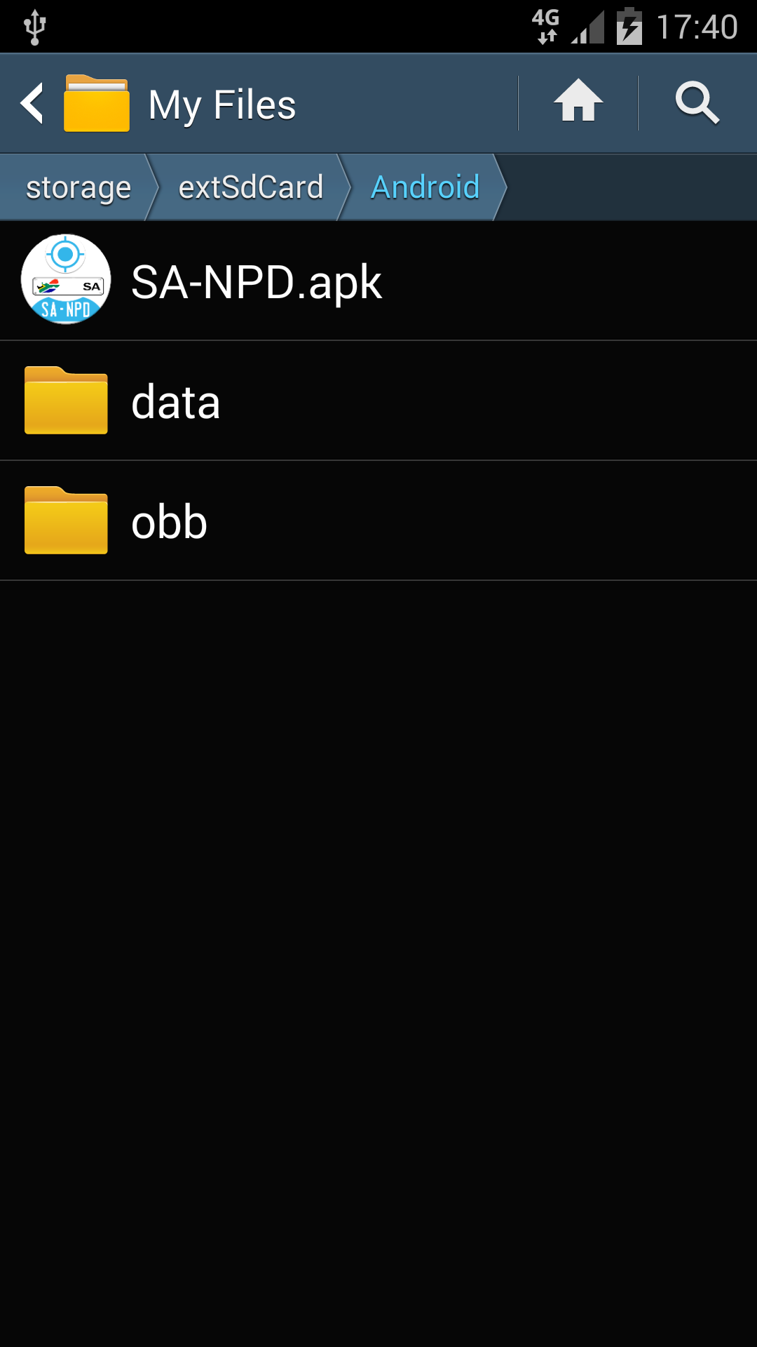

**Figure 1: Installation**

## System Menu

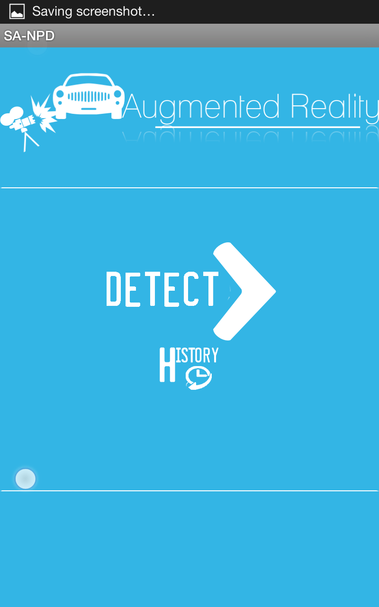SA-NPD is tabbed application, which consists of 2 tabs (Figure 2). The first tab(DETECT) initialize the camera to start the augmented reality system, where detection and recognition of the number plate are made.

Figure 2: SA-NPD

The second tab (HISTORY) lists all previously detected number plates with their details.

## Detect tab

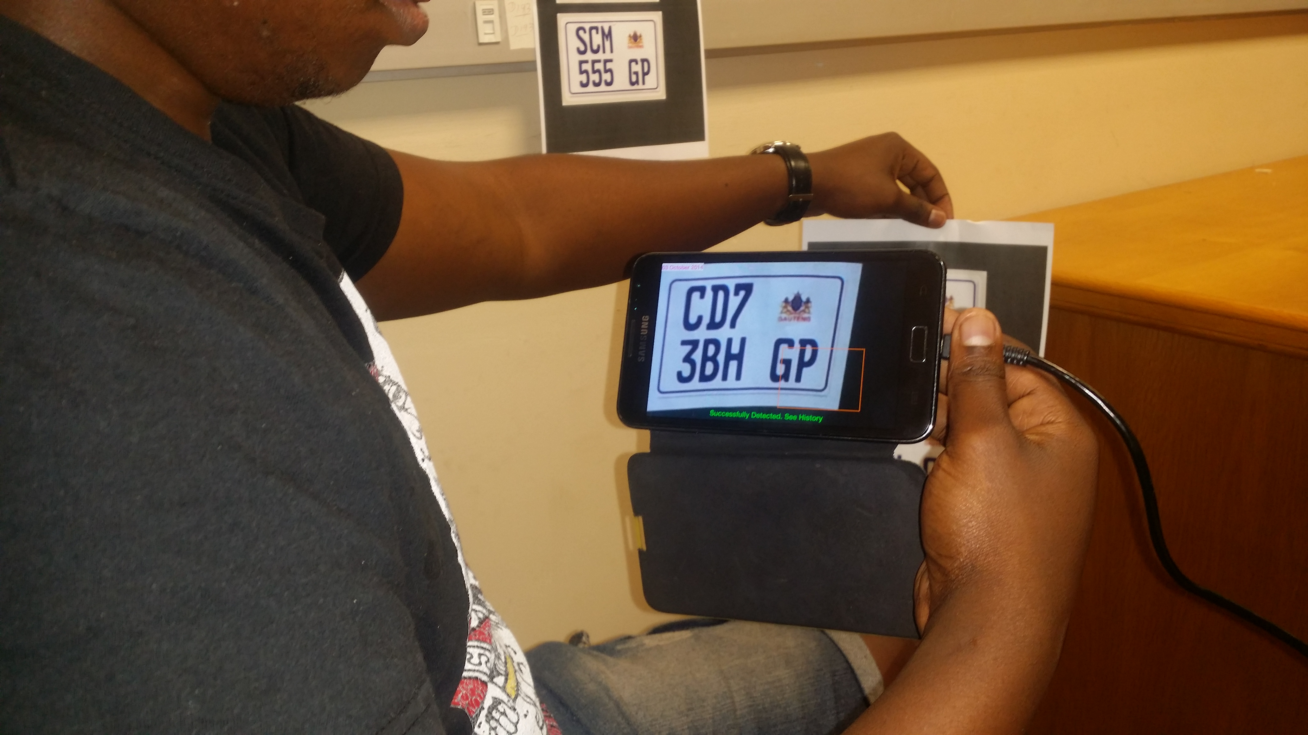

## History Tab

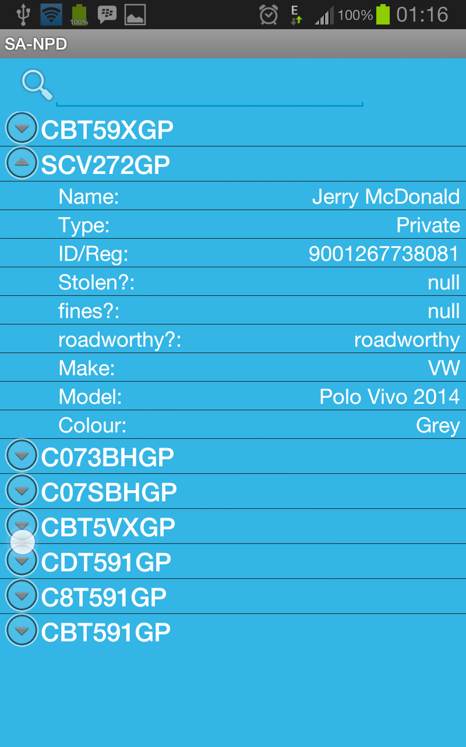

## Exit System

SA-NPD can be closed by selecting Back action on the device.

# USING THE SYSTEM

This section provides a detailed description of system functions.

## Detection tab

## History tab

## Special Instructions for Error Correction

In case if GPS cannot be used to retrieve location data, you may want to use external GPS device and input latitude, longitude, and altitude parameters manually. Similarly, in case of inaccuracy of GPS data you may want to use external GPS device. Note that refreshing GPS coordinates by pressing Get coordinates button few times may increase accuracy of the GPS data